**Lab 1: Forward Characteristics of Diodes; Clipping Circuit**

EE 3310L

Spring 2023

**Alex Yeoh**

Cauy Gibson

Submitted to TA: 1:24am

Date of Experiment: 01/13/23

Date of Submission 01/20/23

1. **Introduction**

The purpose of this lab is to measure and plot the forward characteristics of two types of diodes and investigate a clipping/protection circuit [1].

1. **Experimental Methodology**

The first step of the experiment is constructing the circuit following figure 1 below.

Figure 1. Circuit for exploring the “constant-drop” model for diodes.

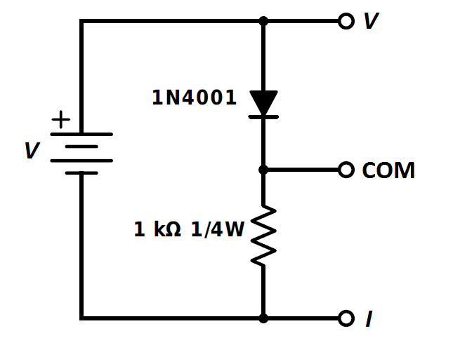

The next step is setting the DC power supply at its lowest setting and measuring the voltage across the resistor while attempting to reach 20mV which corresponds to a current of 20 μA. At this point, measure the voltage drop across the diode. Following this relationship between the voltage and current, fill table 1 below with voltage drop measurements [1].

Table 1. Filled table with voltage drop measurements for the 1N4001 diode and red LED along with when the red LED appeared dim and when it would be bright enough to be a “power on” indicator.

Repeat the previous step after replacing the diode with a red LED while also marking when the LED would be dim and when it would be bright enough to function as a “power on” indicator light [1]. The results can be seen in Table 1 above.

After this portion of the lab, build a different circuit following figure 2 below.

Figure 2: Circuit for exploring protection circuits.

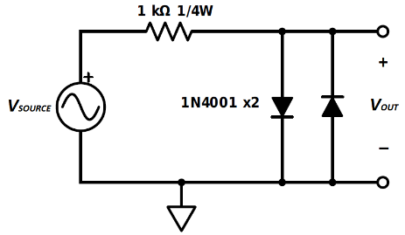

Connect a function generator set to a 1-kHz sinusoid to the source and an oscilloscope to Vout [1]. The voltage is then gradually raised until a wave form distortion begins to appear, at which point the peak-to-peak voltage is recorded [1]. The voltage is then set to the function generator’s highest setting, at which point the peak-to-peak voltage is then recorded again [1]. These two processes that allow for the peak-to-peak values to be recorded are then repeated when both the 1N4001 diodes replaced with red LEDs [1].

1. **Results and Description**

The voltage drop measurements can be seen above in table 1. The peak-to-peak voltages at which the waveforms appear to begin deforming for the 1N4001 diode and red LED were measured to be 900mVPP and 2.9VPP respectively. The peak-to-peak voltages when the function generator has been set to its maximum voltage for the 1N4001 diode and red LED were measured to be 1.38VPP and 3.64VPP respectively.

1. **Discussion**

The requested graph of table 1 from above with the current on the y-axis and set to a logarithmic scale and the voltages on the x-axis and set to a linear scale can be seen below in figure 3.

Figure 3: Plot of VD vs. ID and VLED vs. ILED on the same graph with current on the y-axis and in a log scale and voltage on the x-axis and in a linear scale.

Based on figure 3 above, the constant drop voltages appear to be approximately 0.681V and 1.984V for the 1N4001 diode and red LED respectively.

Based on what was seen in lab for the protection circuits section, the diode clipper circuit did seem to work as intended and limited large peak-to-peak magnitude voltage swings. And the ratio in dB between the maximum peak-to-peak generator voltage and the peak-to-peak voltage of the clipped output waveform appears to be a 9.3 to 1 ratio based on the calculations seen in the equation below.

$\frac{20\log\left(20\right)}{20log⁡(1.38)}=9.3011dB$

1. **Summary and Conclusions**

The lab itself is simple and straightforward to complete due to the instructions given. The lab write-up, however, is a massive burden for a class that does not seem to have the integrated writing attribute listed in the wings express class lookup. This fact feels even more odd due to my previous EE class’s lab only requiring a pre-lab and the given lab sheet filled out to be turned in.

**Reference**

[1] J. Tritschler, *EE 3310L/5310L ∙ Electronic Devices and Circuits Laboratory*, Wright State University, 2023.